UCSF: User’s Account Guide

Contents

Registration Process for Internal Users 1

If Your Account Already Exist 3

How to Find your EmployeeID 4

## Registration Process for Internal Users

1. Navigate to the following URL:  <https://ucsf.ilab.agilent.com/account/login>
2. Bookmark this URL for future use.
3. Once on the iLab login page**,** select ‘Sign in using University of California San Francisco credentials.’
4. At this point you will now be prompted to provide your UCSF username and password.

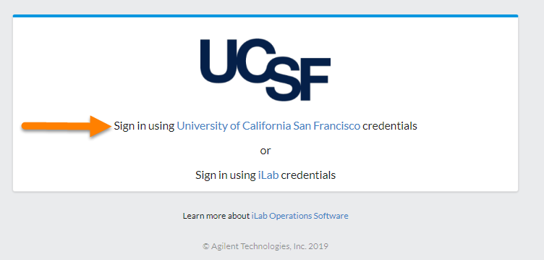

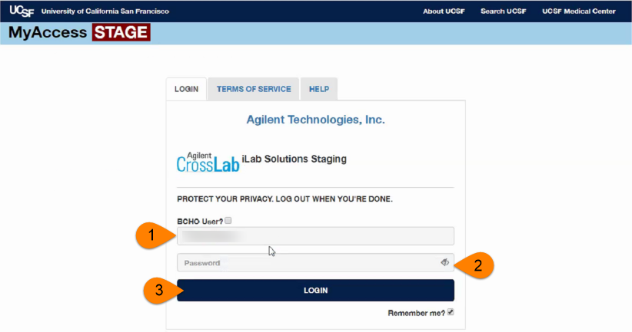

* 1. If you have already registered for an account, you will be brought directly into iLab. If this is your first time logging in, once you authenticate you will be directed to a registration page.

1. First select the appropriate **PI/Group** from the drop-down menu.

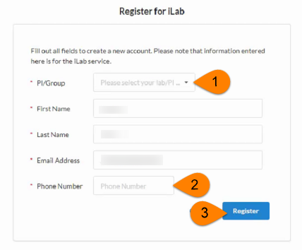

1. Your first name, last name, and email address will be pre-filled and cannot be edited during registration. Complete any remaining fields that have not been pre-filled, such as phone number.
2. Click **‘Register.’** The next page you see will be the “Greeting Page” informing you that your account is pending approval.
3. The PI you selected has been sent an email informing them that they need to approve your account.

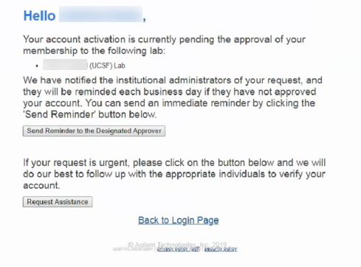

1. The PI is reminded each business day but you have the opportunity to send an additional reminder.
2. You will also receive a Welcome email with brief getting started instructions.
3. Once your account has been approved you will receive an email to notify you**.**
4. Now you can login following steps 1-4 to utilize the core facilities at UCSF within iLab
5. Once logged in you will be directed to the iLab homepage dashboard. Make sure to set your time zone!

## If Your Account Already Exist

Several users have iLab accounts, but their employee ID is not associated with their account. If your account already exists and you attempt to register you will receive an error stating that your email address already exist. Then you will follow the steps to claim your account. When claiming your account your employee ID will be associated with your account. After you have gone through the claim account process you will be able to login to iLab.

## How to Find your EmployeeID

If you have reached out to iLab support for assistance and they ask for your EmployeeID. there are a few ways to locate your UCSF ID number. One way is from the MyAccess home page - at the top click MyID as pictured below, your ID number should appear next to your name. You can also contact your department manager or IT representative to locate your ID number which is required for a new MyCORES account.

https://rrp.ucsf.edu/sites/g/files/tkssra351/f/wysiwyg/MyID.JPG

Registration Process for External Users

Anyone that does not have a UCSF email and does not belong to a UCSF PI’s lab is considered external. These users will register for an iLab account if they do not already have one.

1. Navigate to the following URL:  <https://ucsf.ilab.agilent.com/account/login>
2. Bookmark this URL for future use.
3. Once on the iLab login page**,** select ‘Sign-Up’ in the upper right-hand corner.
4. Select the option ‘Not a University of California San Francisco user?’
5. If you do not have an iLab account already iLab will direct you to register.
   1. Note: If you are part of another institution that has an ID/SSO integration with iLab, you will be brought to their customized login page and process.
6. Within the registration process you will provide general information about yourself, PI contact information, and billing information.
7. If your institution and PI already exist in iLab, your account is automatically created.
8. If your institution OR PI does not exist, your account will be sent to the iLab support team to be approved.
9. Allow 24-48 hours for your account to be approved.
10. If you need your account sooner than 24-48 hours contact [ilab@ucsf.edu](mailto:ilab@ucsf.edu) and they will contact the iLab Project Manager.

**Assigning Price Types to Users**

UCSF has 4 different price types/rates that can be assigned to a user. By default internal users, users with a UCSF email address and live within a UCSF lab in iLab, receive the ‘Internal’ price rate. By default external users, users without a UCSF user and live within a different institution, receive the ‘External not for profit’ price rate. If a user should receive a different price type/rate that must be assigned on the pricing panel within your core. These price types can be assigned to an entire institution, a PI’s lab meaning anyone in the PI’s lab will receive that price type, and the individual user.

1. Navigate to the ‘Administration’ tab within your core
2. Select the first panel called ‘Pricing’
3. Within the text box begin typing the institution, PI, or user’s name
4. Within the results find the correct name
5. On the far right click the drop down menu to choose the price type you need to assign
6. Click ‘Share Price’
7. The institution, PI, or user then will appear in the list ‘existing price permissions’ with the price you granted

