University of California San Francisco: Billing Manual

Contents
Overview 1
Logging into iLab: 1
Billing Process: 4
Generate Billing Event for Review 4
Review a Billing Event and Generate Invoices and Billing File 5
Invoices: 7
Refunding a Charge 9
How to initiate a refund: 9

Overview

The iLab/UCSF Financial Integration allows PIs, Financial Managers, Researchers and Core Managers to use valid payment information (SpeedTypes) at each step of the request and billing process for core facilities. This document will review the billing process that UCSF has put into place.

Logging into iLab:
- Navigate to the following URL: https://ucsf.ilab.agilent.com/account/login
- Bookmark this URL for future use.
- Once on the iLab login page, select ‘Sign in using University of California San Francisco credentials.’
- At this point you will now be prompted to provide your UCSF username and password.

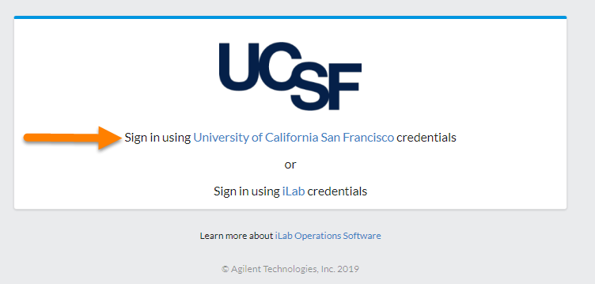

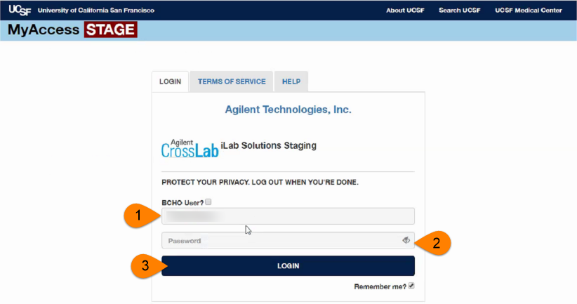

  - If you have already registered for an account, you will be brought directly into iLab. If this is your first time logging in, once you authenticate you will be directed to a registration page.
- First select the appropriate PI/Group from the drop-down menu.

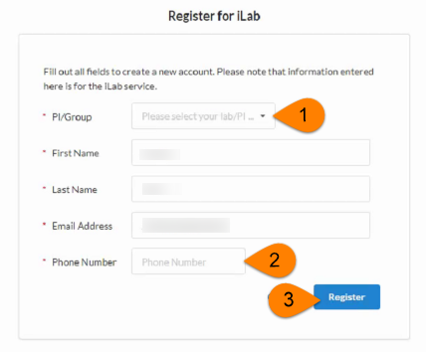

- Your first name, last name, and email address will be pre-filled and cannot be edited during registration. Complete any remaining fields that have not been pre-filled, such as phone number.
- Click ‘Register.’ The next page you see will be the “Greeting Page” informing you that your account is pending approval.
- The PI you selected has been sent an email informing them that they need to approve your account.

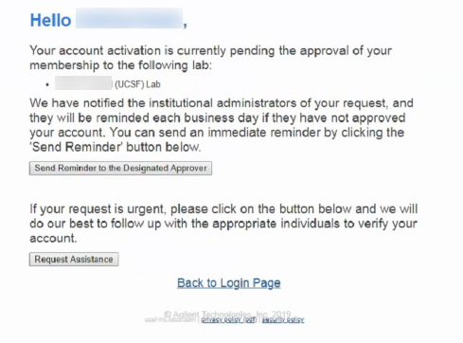

- The PI is reminded each business day but you have the opportunity to send an additional reminder.
- You will also receive a Welcome email with brief getting started instructions.
- Once your account has been approved you will receive an email to notify you.
- Now you can login following steps 1-4 to utilize the core facilities at UCSF within iLab
- Once logged in you will be directed to the iLab homepage dashboard. Make sure to set your time zone!

Billing Process:
UCSF follows a centralized billing workflow which means there is a central point of contact who will generate billing files and invoices then send the final billing file to Peoplesoft.

Cores must submit all draft billing events no later than 11:59pm on the last calendar day of the month – We will send a reminder to do so one week prior to month close, which will typically (not always) occur on the 2nd business day of the following month.

Generate Billing Event for Review
Generating the billing event for review is the core admin/staff’s responsibility. Core administration can see a summary of all charges marked as Ready to Bill in one location on the core’s Billing tab. Here the core administrator can load the charges they want to review using the End Date and Include filters. After reviewing the Ready to Bill charges, the core admin can either choose to create a Draft Event including the charges they want to review further or approve the charges for billing by clicking on Ready for Review.

- Navigate to the Billing tab on your core
- Click ‘New Billing Event’
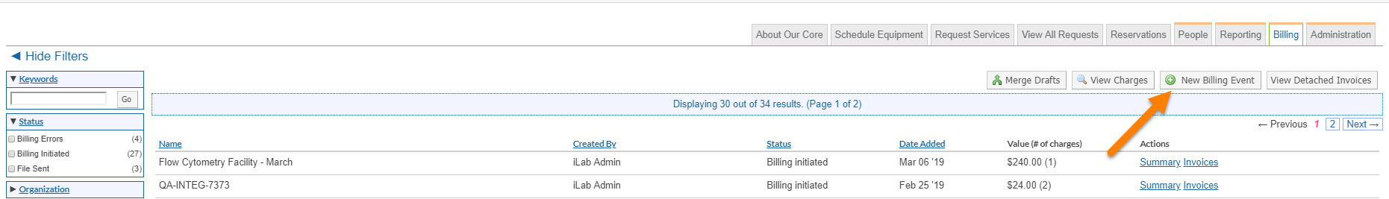

- Select which charges to view using the filters
  - End Date: This will include any Ready to Bill charges up to and including this date
  - Event Name: Modify the name of the billing event
  - Choose to include both internal and external charges on this event or separate them
- Review the charges and edit payment information if necessary
- Select “Ready for Review”
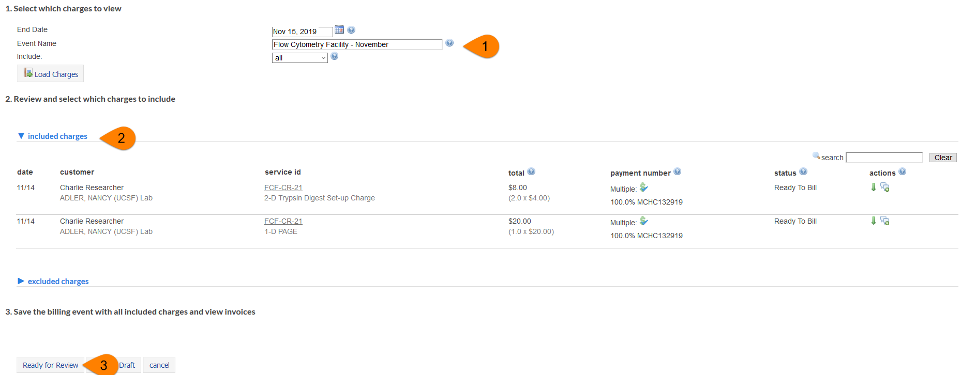

Review a Billing Event and Generate Invoices and Billing File
At month close, which is typically (but not always) the 2nd business day of the following month, the designated central biller will generate all billing events that are in a Pending Review status. When generating the billing event the invoices and custom billing file will be generated as well as invoices will automatically be sent to appropriate owners. Once billing events have been created the central biller will send the billing file to PeopleSoft.

Generating and Sending Billing Files at the Institution Level:
- Navigate to the billing tab on the institution dashboard
- Click the ‘Bulk Actions’ button on the right above the list of billing events
- Choose ‘Create billing file and invoices’
  - This will create the billing file and invoices for any billing events that are in a ‘Pending review’ status
  - This will also automatically send all invoices to invoice owners.
- Click ‘Send Billing Files to ERP’ when you are ready to send the billing files to PeopleSoft.
- The file will be in a ‘Ready to Send Status’ till iLab picks up the file to drop on the server at 11:00am or 3:00pm daily.
- Once iLab drops the file on the server the status will be ‘File Sent’

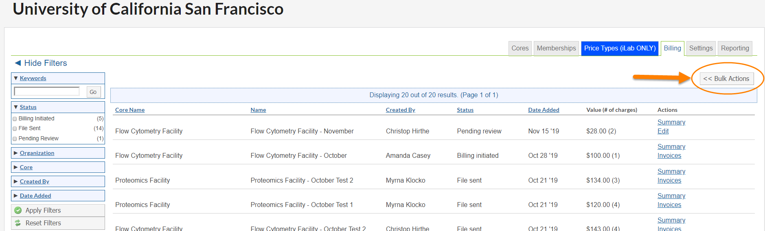

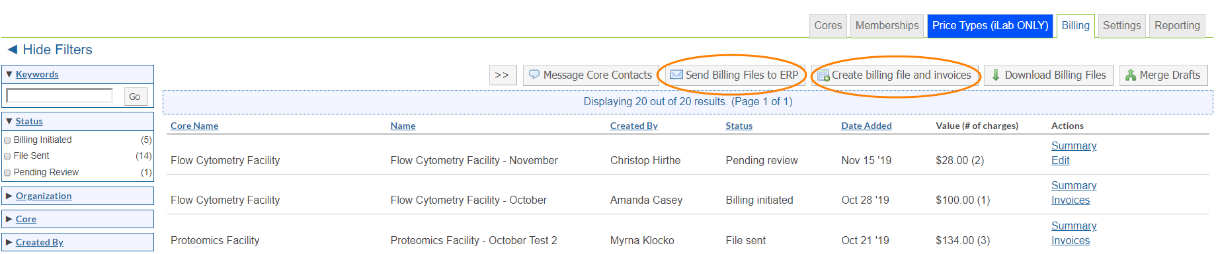

Generating and Sending Billing Files at the Core Level:

- Navigate to Billing tab on institution dashboard
- Use the filters to the left to filter by Status, ‘Pending Review’
- Click ‘Apply Filters’
- Click ‘Edit’ next to billing event that is ready to be reviewed
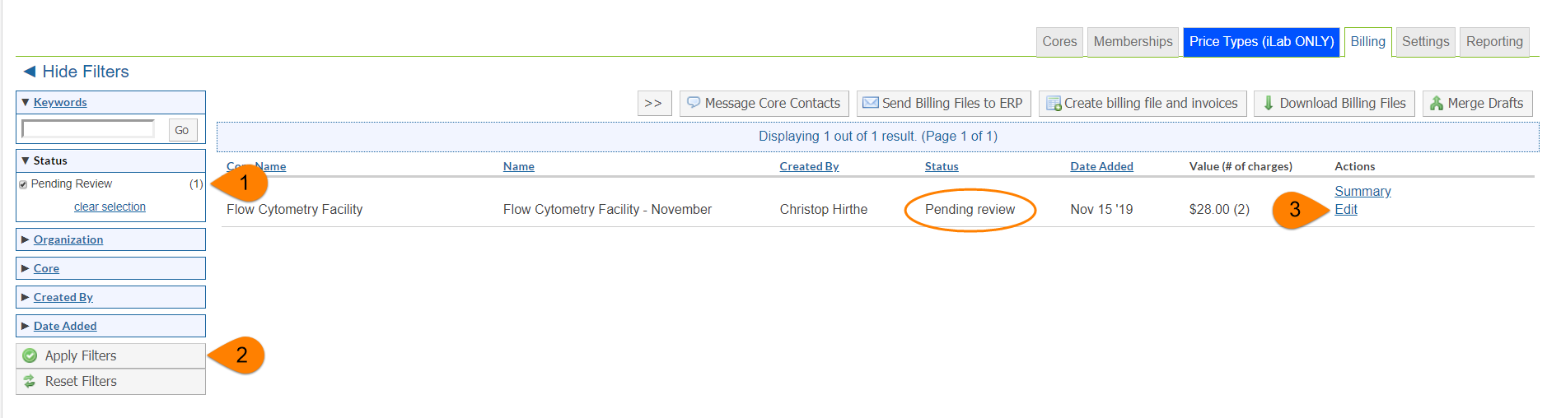
- Review and make modifications if necessary
- Click ‘Create Billing File and Invoices’
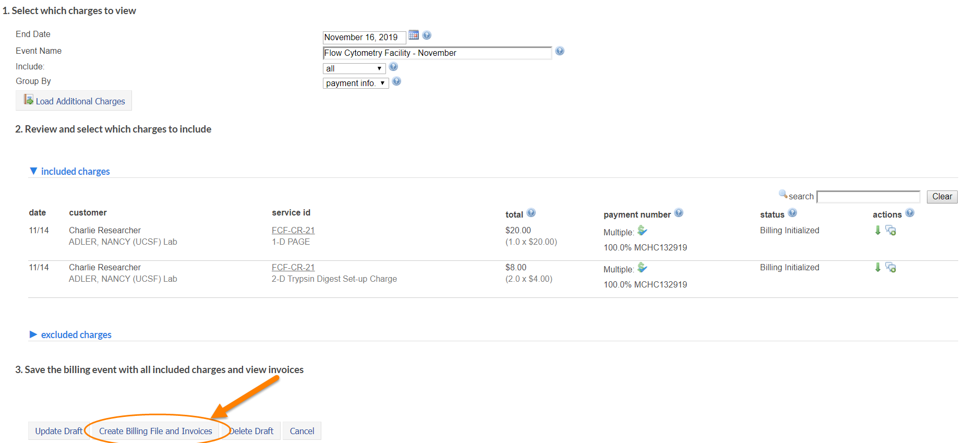
- Generating billing events and invoices at the core level will not automatically send invoices.
- When the billing file is ready to be sent click ‘Send File to ErpUcsf.’
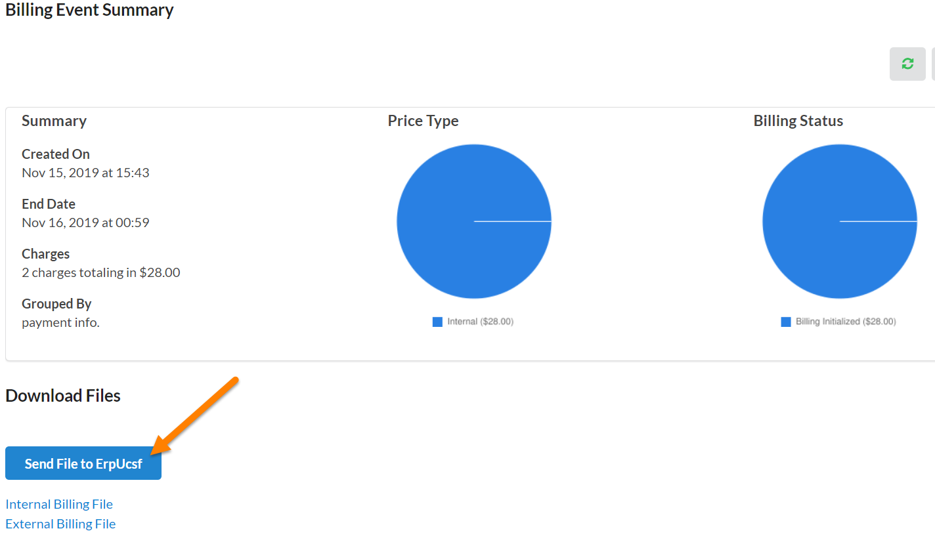
  - The file will be in a ‘Ready to Send Status’ till iLab picks up the file to drop on the server at 11:00am or 3:00pm daily.
  - Once iLab drops the file on the server the status will be ‘File Sent’

Invoices:
Core facilities will create billing event drafts to bill for. Once the billing event draft is created it will be reviewed by an institution admin. The institution will generate the final billing event and invoices.
- Click ‘Invoices’ in the left-hand menu to see a list of all invoices.
  - For core staff, PIs, lab managers, and users only the invoices that are part of your core, lab, or you are the requester on will appear.
- Use the filters to reduce and sort the invoices that display.
- Click the magnifying glass on the right of the invoice row to view the invoice.
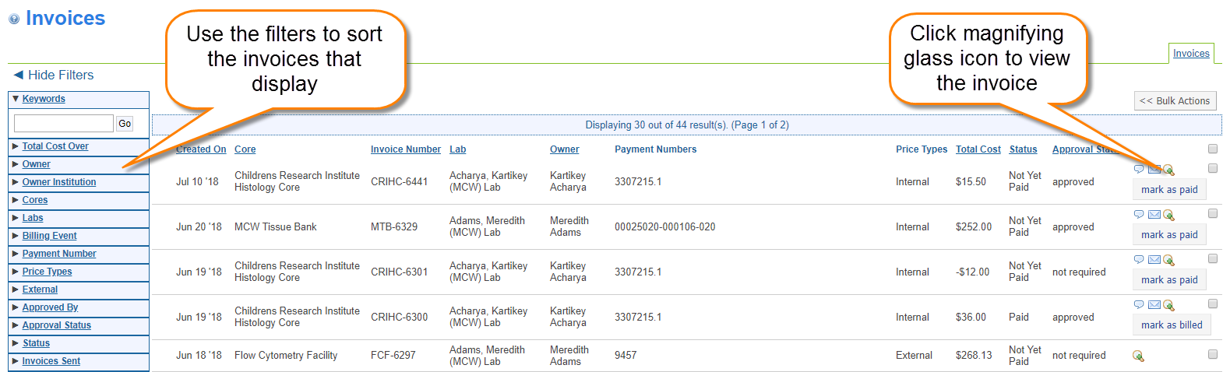

Splitting Charges on an Invoice:
Charges can be split between Speedtypes within the core when the user is creating their request/reservation, on the View All Request tab, on the billing tab under view charges, while creating a billing event, and on the invoice prior to the billing file being sent to Peoplesoft.
- Click on ‘Invoices’ in the left-hand menu
- Then click the magnifying glass to view the live invoice.
- Review the charges and then click the $ icon to split the Speedtype being charged
- Select a charge in the payment list that needs to be split
- Select ‘Split Charges’
- Set your percent allocation, must equal 100%
- Select which speedtypes are to be charged from the drop down
- Click ‘Save’
