Gladstone and SF VA Medical Center PI and User Process

Gladstone Users and PIs

Gladstone utilizes iLab for their core facilities and their PIs have labs within Gladstone. Some Gladstone PIs need to utilize UCSF Speedtypes but since the PI does not come through in the nightly fund file their lab needs to be created manually, PI needs to be added to the lab, members of that PI’s lab need to be added, Speedtype needs to be added to the lab and assigned to members. This document outlines the process for Gladstone PIs and Users.

Gladstone user request access to UCSF lab
- Click the hamburger icon in the upper left-hand corner of iLab to expand your left navigation menu
- Click ‘Manage Groups header to
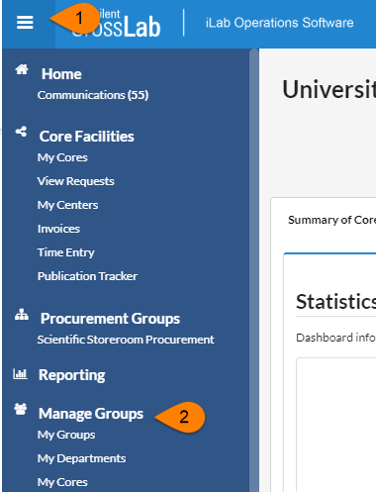

- Click the grey “Request Group Access” box under your list of groups
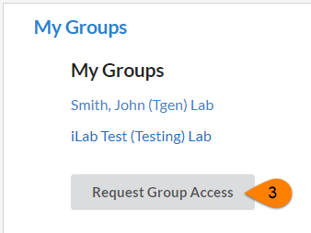

- Type ‘San Francisco’ in the ‘Institution’ box then choose ‘University of California San Francisco’ from the list of institutions
- Within the ‘Group’ box type your PI’s last name for the list of PIs to populate
- Select your PI
- Click ‘Request Access’
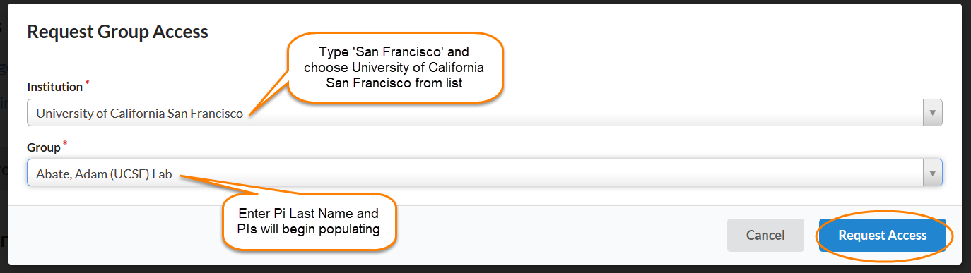

- Your PI, lab manager, or an institution admin at UCSF will have to accept your request

