**New Services through the LCA Genome Core at Mission Bay**

* ***Biomarker and Imaging Services***

We are excited to announce that the [LCA genome core](https://cancer.ucsf.edu/research/cores/lca/lca-genome) is now offering advanced **biomarker optimization services and imaging services**. Requests for these services can be submitted through iLab under the LCA Genome Core. For questions or quotes, feel free to contact us at: [genome1@cc.ucsf.edu](mailto:genome1@cc.ucsf.edu)

* ***Tecan Library Prep Automated Systems***

The MagicPrep NGS system is a new category of automated laboratory equipment that simplifies NGS library preparation for Illumina sequencing platforms (DNA and mRNA). It offers a complete solution with pre-optimized scripts, reagents, and consumables. Learn more about the [MagicPrep NGS system here](https://www.tecan.com/magic)

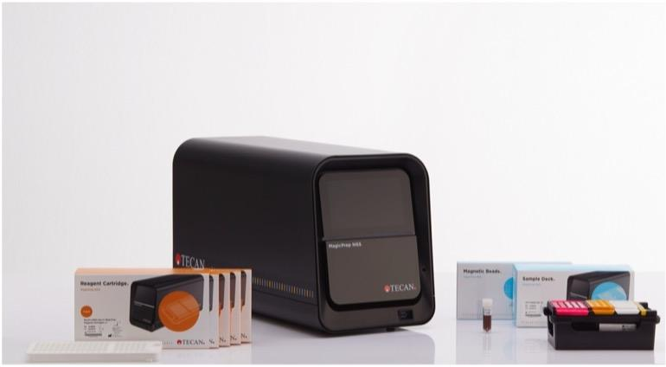

* ***Single-cell transcriptomics in situ with 10X Genomics Xenium technology:***

Xenium is a state-of-the-art single-cell, high-resolution, imaging-based, spatial profiling technology from 10x Genomics. It allows for simultaneous expression analysis of RNA targets—up to 5,000—within the same tissue section. We provide both full service and training sessions. Learn more about 10X Genomics Xenium he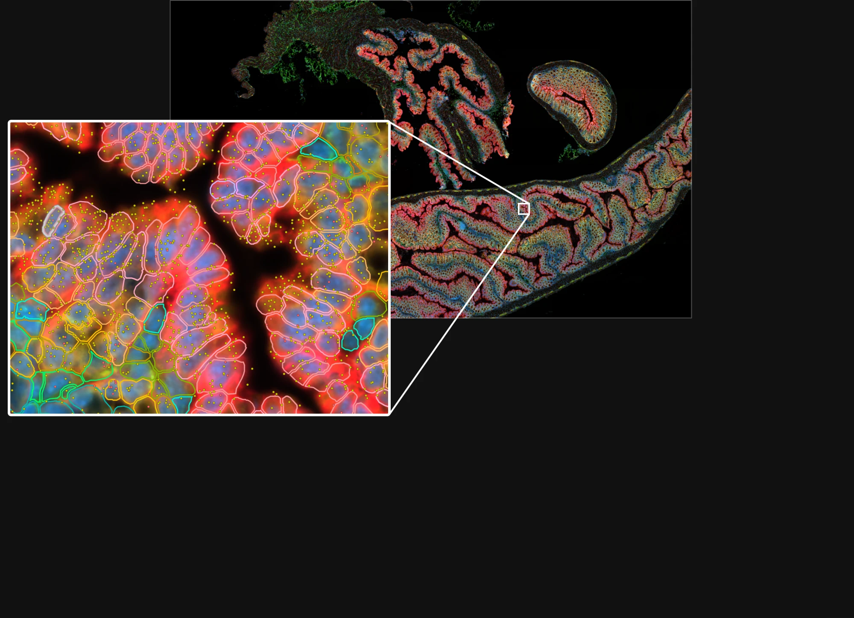re.

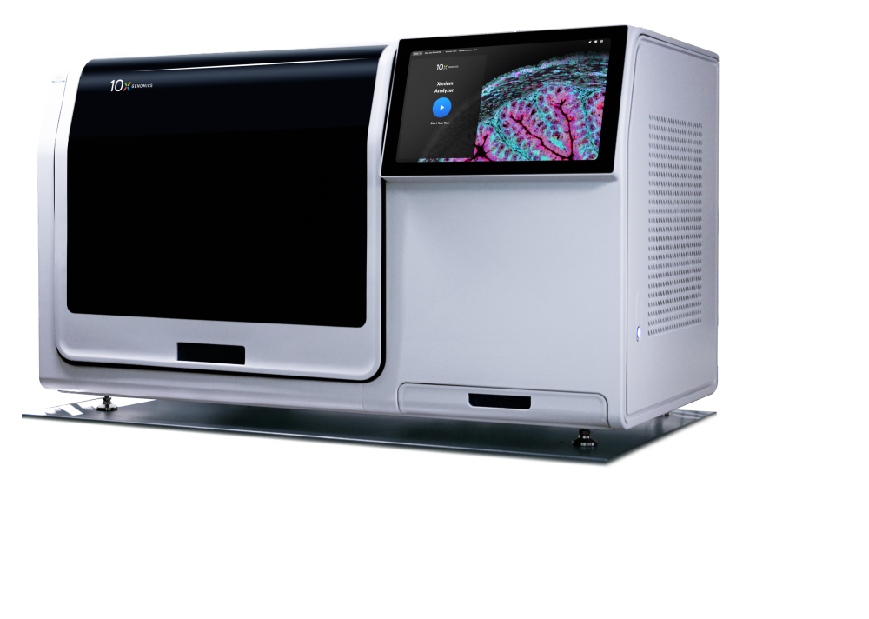

***Other key offerings include:***

* ***Multiomics tissue profiling with Nanostring GeoMx technology:***

Spatially profile the whole transcriptome and over 570 protein targets, either separately or simultaneously, from your choice of sample inputs: whole tissue sections, tissue microarrays (TMAs), or organoids. Comprehensive services and training are available. Discover more about [GeoMx Nanostring technology here](https://nanostring.com/products/geomx-digital-spatial-profiler/geomx-dsp-overview/)

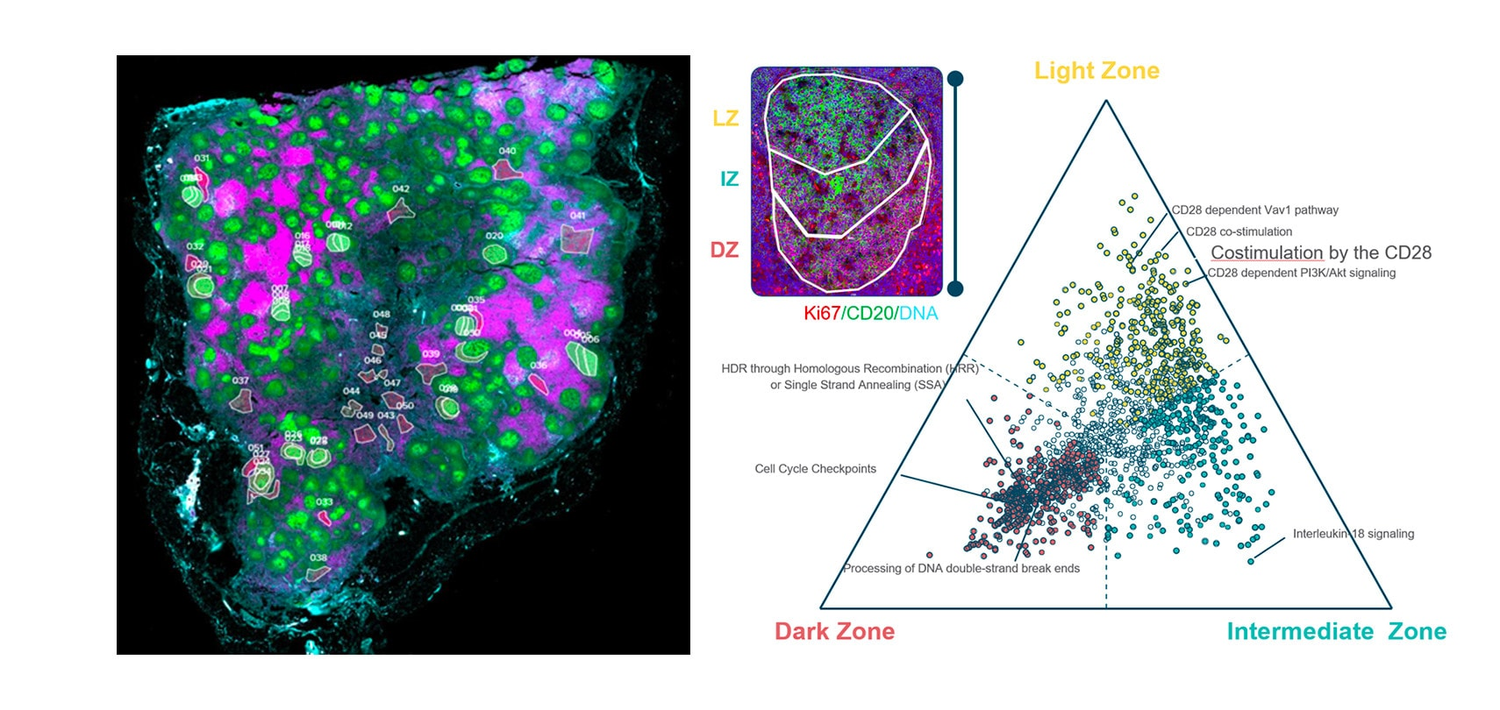

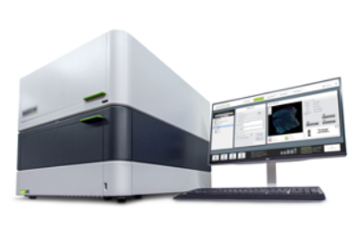

### ***Nanostring nCounter Spring***

The nCounter® platform provides a simple and cost-effective solution for multiplex analysis of up to 800 RNA, DNA, or protein targets. Learn more about the [nCounter](https://nanostring.com/products/ncounter-assays-panels/oncology/)  technology and panels here.

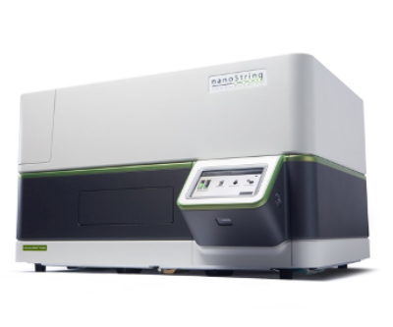

* ***Liquid Handler EpMotion:***

[EpMotion 5075](https://online-shop.eppendorf.us/US-en/Automated-Pipetting-44509/Liquid-Handling-Workstations-44510/epMotion5075LH-PF-14372.html?_ga=2.7612146.1587745248.1574362941-1704670477.1574102635) is an automated liquid handling system linked to a desktop computer software is designed for effective, automated liquid handling applications providing a precise, accurate alternative to time-consuming manual pipetting and liquid handling tasks. For inquires and protocols development please contact Dr. Benjamin Braun at [Ben.Braun@ucsf.edu](mailto:Ben.Braun@ucsf.edu)

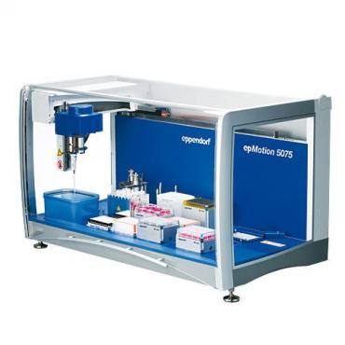

Take advantage of these cutting-edge technologies and elevate your research with the LCA Genome Core! Submit your inquiries to [genome1@ucsf.edu](mailto:genome1@ucsf.edu).